APPENDIX G - ENUMERATING RHIZOBIA IN BROTH, INOCULANTS AND SOILS*

Routine enumeration techniques for determining the total and viable numbers of cells in a pure broth-culture of Rhizobium are described. The mean generation time of Rhizobium in broth culture is computed.

Key steps/objectives

1) Inoculate yeast-mannitol broth with Rhizobium

2) Calibrate Pasteur pipettes

3) Determine the total count

4) Measure the optical density of the broth cultures

5) Make a serial dilution and plate by the pour-plate, spread-plate, and drop-plate methods

6) Read and calculate the viable counts obtained by the three methods

7) Compare results of the counting methods

8) Inoculate flasks with diluted culture(s) for the generation time experiment

9) Determine viable counts periodically

10) Plot growth curve and determine the mean generation time.

(a) Preliminary culturing of fast- and slow-growing rhizobia (Key step 1).

Inoculate two flasks each containing 50 ml of YM-broth with a fast-growing Rhizobium phaseoli strain, TAL 182, and two other flasks with a slow-growing Rhizobium japonicum strain, TAL 379. Incubate the flasks at 26°C on a rotary shaker at 20 rpm. TAL 182 should be started 4-5 days in advance of the exercise; TAL 379, 7-9 days in advance. Take the culture of TAL 182 from the shaker after 4-5 days and remove a 20 ml subsample for the procedures (b) and (c).

(b) Determining the total count with a Petroff-Hausser chamber (Key step 3).

The Petroff-Hausser counting chamber (Figure 4.1) is a precision-machined glass plate that has a sunken platform at its center. The surface of this platform is exactly 0.02 mm below the surface of the plate and is etched with a grid system which consists of 25 larger squares, each of which is divided into 16 smaller squares. Because of the precisely machined gap between the grid surface and the overlying glass coverslip, it is possible to relate the number of cells observed in a field bounded by the sides of these squares to the volume of fluid in which they are suspended. Knowing the volume of each square, the concentration of rhizobia (total cells/ml) can be calculated.

The following data apply to the Petroff-Hausser counter as well as the Helber counter which has a grid system of an identical design.

Brief details of the Petroff-Hausser counting chamber
Squares | Corresponding  Volume (ml) | Factor  (1/volume)
Total grid area | 2 x 10⁻⁵ | 5.00 x 10⁴
Large square | 8 x 10⁻⁷ | 1.25 x 10⁶
Small square | 5 x 10⁻⁸ | 2.00 x 10⁷

The large squares are most suitable for counting rhizobia. The countable range is 8-80 cells per large square.

(c) Using the Petroff-Hausser counting chamber (Key step 3)
Chamber and coverslip should be soaked in a mild liquid detergent and thoroughly rinsed with distilled water and then air dried. This will assure an even flow of the liquid into the chamber and prevent the forming of air bubbles.

A fully grown broth-culture contains approximately 10⁹ cells per ml. Make a 1:10 dilution with sterile water to bring the suspension within a countable range. From this dilution, make another dilution series in sterile water of 10, 20, 40, and 80%. Choose the dilution which you consider within the best counting range. Trial runs with the various dilutions may be needed to select the best dilution for the count. This may require washing and drying the counting chamber several times, until the best dilution has been determined.

Slide the clean Petroff-Hausser chamber into its frame and place the coverslip into position and press it down lightly to assure a firm seating on the supporting surface of the chamber.

The frame of the Petroff-Hausser chamber has a small indentation on the inside of one of its long edges. To this area, deliver a small drop of the diluted culture suspension using a fine tipped Pasteur pipette.

The Rhizobium suspension will quickly spread over the grid. Excess culture (if more than one drop was added) will overflow into the two channels at the edges of the etched platform. If these channels flood completely, the coverslip may not rest flush on the surface of the glass plate. If this happens, clean the counting chamber and start again.

Place the chamber under the 40 x objective of a phase-contrast microscope. Count cells in individual large squares. To avoid counting the same cells twice, omit bacteria on the upper and left borderlines of each square. Count at least ten fields (8-80 cells per large square) to obtain coefficients of variability of 10%.

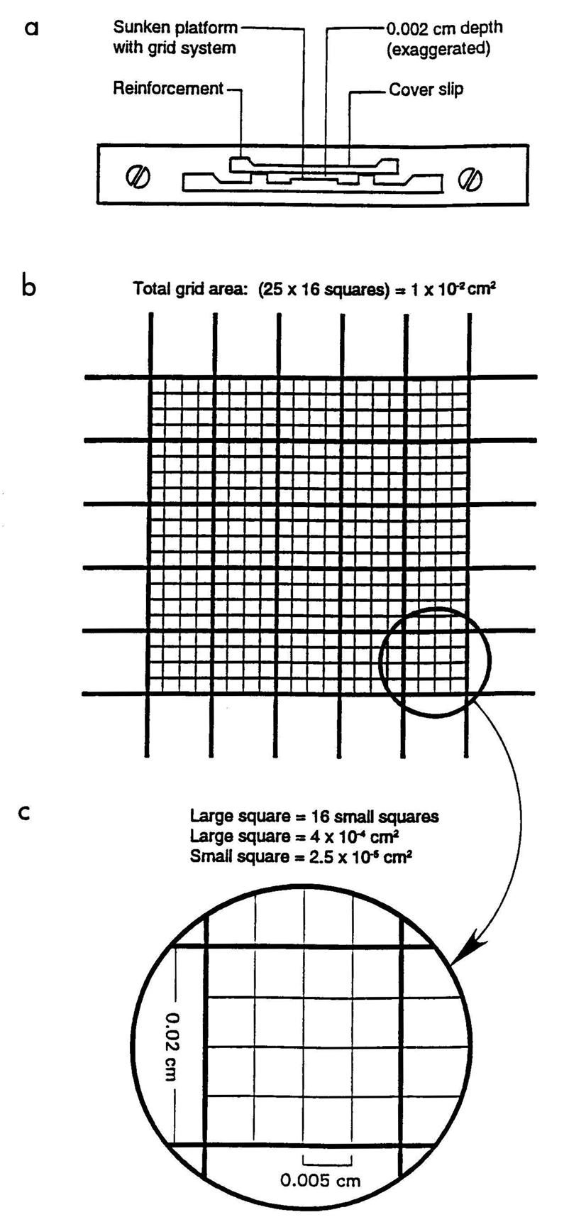

Figure 4.1 Petroff-Hausser counting chamber

Figure 4.2 Procedure for serial dilution

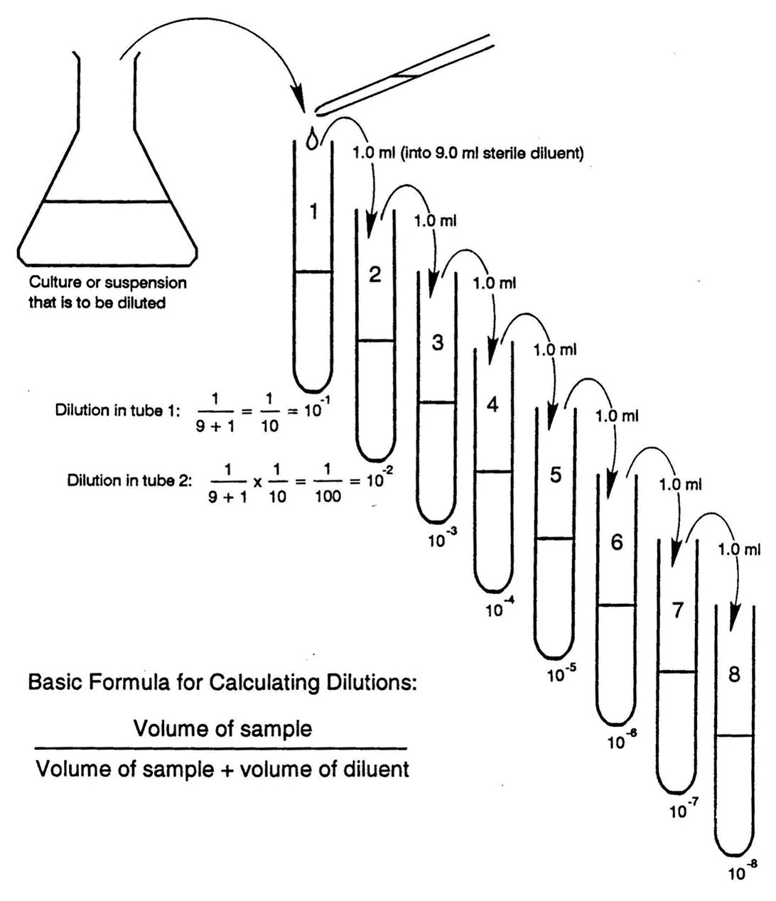
Use the following formula to calculate the number of cells: Bacteria in original cell suspension = dilution x cells per square x factor for square.

If 20 cells were counted in a large square and the original broth culture was diluted by a factor of 10⁻², and if a 20% suspension of this dilution was counted, the total number of rhizobia per ml of broth would be:

20 x 100 x 100 x 1.25 x 10⁶ = 1.87 x 10⁹
20

Remember that the count included dead as well as viable rhizobia and also the cells of contaminants, if present. Most direst counts are of variable reliability in that they overestimate the viable-count by a factor of more than two, i.e., 50% or more of the cells counted may be dead. This method is suitable only for counting cells in liquid media, and not in peat, soil, or other particulate materials.

(d) Estimating cell concentration by optical density (Key step 4).

The optional density of a bacterial suspension is generally correlated with the number of cells it contains. Optical density measurements are a simple and convenient method for the estimate of cell numbers as they require but little manipulations and aseptic conditions need not be observed.

Dilute 5-10 ml of the TAL 182 broth culture to 10, 20, 40, and 80% of its original concentration. Measure the light absorbed by each concentration with a spectrophotometer at a wavelength of 540 nm. relate the different concentrations to the actual cell count obtained with the Petroff-Hausser chamber by plotting the Optical Density (O.D.) against the total cell number. This method also has its limitations.

It is best suited for initially clear media. Dead cells and contaminants contribute to the O.D. of the culture, as well as gum produced by the rhizobia, undissolved salt or precipitate in the medium.

(e) Determining the number of viable cells in a culture by plating methods (Key steps 5, 6, and 7).

Make serial dilutions of the TAL 182 broth culture. Based on the total count, the number of viable cells will probably be around 1.0 x 10⁹ cells/ml. A countable range for plate counts is 30-300 cells/ml. To achieve this concentration, set out 8 tubes each, containing 9 ml of sterile diluent (1/4 strength YM broth, pH 6.8). One ml of the broth culture is diluted in steps, tenfold each time (10⁻¹ through 10⁻⁸). Refer to Figure 4.2 for the serial dilution procedures.

Use a fresh pipette for each strain and for each dilution in the series. Begin with the highest dilution in the series, With the aid of the suction bulb, fill and empty the pipette by sucking in and out 5 times with the diluted culture, then transfer 1 ml aseptically to a sterile Petri dish. Open the Petri dish only sufficiently to allow the pipette to enter and deliver the sample. Flame the pipette briefly (but do not overheat) by passing it through the bunsen burner flame each time prior to successive removal of aliquots for replication (2 per dilution) from the same tube. Similarly with the same pipette remove 1 ml aliquots in duplicate from the 10⁻⁷ and 10⁻⁶ dilutions into more Petri dishes.

Pour 15-20 ml YMA (kept melted and equilibrated at 50°C in a waterbath) aseptically onto each of the cell suspensions in the Petri dishes. To disperse the cells evenly, gently move each Petri dish clockwise and counterclockwise allowing an equal number of swirls in each direction. To further ensure uniform dispersion of the cells, move the Petri dish three times forward and backward, then to the left and right. Allow the agar to set, invert the dishes and incubate at 26° - 28°C. Read the plates after 3-5 days. You have now completed the pour-plate method.

Prepare serial dilutions of TAL 379. Make pour plates with dilutions 10⁻⁸, 10⁻⁷, and 10⁻⁶ in duplicates. Incubate the plates for 7-9 days, checking daily during the incubation. Lens shaped colonies develop in the YMA and normal colonies develop on the surface.

Multiply the average number of colonies by the dilution-factor. If the average number of colonies at 10⁻⁷ dilution is 50, then the original broth culture had a concentration of:

(number of colonies) x (dilution factor) x (vol. of inoculum)

(50 colonies) x (10⁷) x (1.0ml)

= 50 x 10⁷ cells per ml = 5.0 x 10⁸ cells per ml

A similar technique called the spread-plate method is also commonly used. Use the same serially diluted samples of TAL 379 prepared for the pour plate method above. Begin with the 10⁻⁷ dilution and deliver 0.1 ml of the sample into each of 4 plates of YMA previously dried at 37°for about 2 hours. Using the same pipette, dispense 0.1 ml samples from the 10⁻⁶ and 10⁻⁵ dilutions, in that order. Prepare a glass spreader by bending a 4 mm glass rod to the shape of a hockey stick, dip in alcohol, and flame; then cool the spreader by touching it to the surface of a separate YMA-plate. Lift the cover of each Petri-dish just enough to introduce the spreader and place it in position on the agar surface. Spread the sample evenly over the agar surface, sterilizing and cooling the spreader between samples. Incubate as before. Calculate the number of viable cells as outlined for the pour plate method, adjusting for the smaller volume that was plated (0.1 ml instead of 1.0 ml).

Both of the above methods are lengthy and require a large number of Petri dishes. A variation known as the Miles and Misra drop-plate method is more rapid and consumes less materials. Use agar plates which are at least 3 days old or have been dried at 37°C for 2 hours. Mark off 8 equal sectors on the outside bottom of the Petri dish. Label 4 sectors for replications of one dilution and 4 for another, allowing two dilutions per plate.

For this technique calibrated pipettes are required. Calibrate at least 10 pipettes by the following method:

Determine the weight of 100 drops of water on a sensitive balance or the volume of 100 drops of water in a small measuring cylinder.

Calculate the weight or the volume of a single drop by dividing the total weight or volume by 100.

Pipettes with the same tip diameter (e.g. external diameter of 1 mm) deliver drops of virtually the same volume. After the drop size of a calibrated pipette has been established, more pipettes of the same tip diameter may be selected using a wire-gauge. Alternatively, any Pasteur pipette may be cut to the same tip diameter with a fine file after matching its tip with a wire gauge.

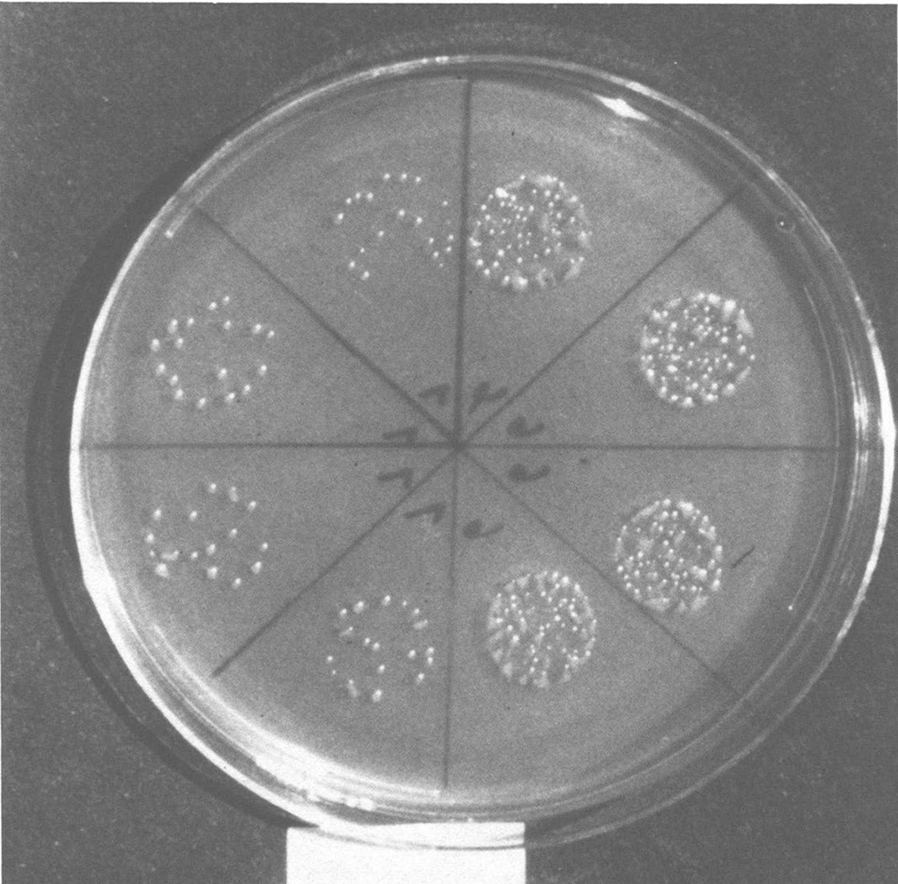

Figure 4.3 Growth of colonies of Rhizobium sp. from drops plated by the drop-plate method

Use the dilution series of TAL 379 which had been prepared earlier. Plate dilutions of 10⁻⁷, 10⁻⁶, and 10⁻⁵. Begin with the highest dilution and deliver one drop to each of the appropriate 4 sectors of the plate. Use a calibrated Pasteur pipette equipped with a rubber bulb.

While holding the pipette vertically, about 2 cm above the agar surface, exert just enough pressure on the bulb to deliver one drop at a time. Use the remaining 4 sectors of the plate for the next dilution. Allow the drops to dry by absorption into the agar; then invert and incubate at 26°- 28°C.

The drop-plate method requires more skill than the other methods. Results may not match those of the pour-plate and spread-plate methods at the first attempts. It is advisable to practice drop-plating with plain water before using this method for the first time. Fewer colonies per drop require more drops to be counted to provide the same statistical precision.
After 3-5 days of incubation, with daily observations, count the colonies formed by TAL 182. Place an open Petri dish, inverted, on the illuminator of a colony counter. With a fine tipped felt pen, mark each colony-counted while simultaneously operating a tally counter. Record your counts.

If a pipette with a 14 gauge tip was used, one drop would be 0.03 ml. Divide 1 ml by 0.03 and multiply by the dilution factor and the average number of colonies per drop. Example, if the average number of colonies per drop is 60 at 10⁻⁵ dilution, the number of viable cells are:
1/0.03 x 60 x 10⁵ = 2000 x 10⁵ = 2 x 10⁸/ml

Compare the viable count of TAL 182 with its total count and calculate the percentage viability to the original culture.

At the end of a 7-10 day incubation period, count the colonies of TAL 379 on plates prepared by the three methods. Calculate the number of viable cells per ml and compare the results obtained by the different methods. Discuss the advantages and disadvantages of the three plating methods.

Bear in mind that plate counts, of whatever variety, are of value only for counting the viable rhizobia in pure culture. There is no selective medium that permits growth of Rhizobium alone. Therefore, quantifying Rhizobium in soil is difficult. Also, the plating methods do not distinguish between strains of species of Rhizobium having similar visual characteristics on YMA. When it is necessary to quantify the occurrence of viable cells of a particular Rhizobium in non-sterile materials, a plant infection method must be employed.

(f) Determining the mean-generation (doubling) time of rhizobia (Key steps 8, 9, and 10).

The time required for a doubling of a given cell population is referred to as the generation time.

The growth of Rhizobium in broth culture is followed for a period of 7 days. viable counts are made each day throughout the duration of the experiment. A growth curve is obtained by plotting the viable count versus time. From the curve, the mean-generation (doubling) time is computed.

Two strains of Rhizobium the fast growing TAL 182 (R. phaseoli) and the slow-growing TAL 379 (R. japonicum) are used in this experiment.

A total of sixteen 250 ml Erlenmeyer flasks, each containing 100 ml of YM-broth into each flask and sterilize.

Prepare 32 flasks for the two strains. Measure accurately 100 ml of YM-broth into each flask and sterilize.

Obtain 1 ml each of the fully grown cultures of TAL 182 and TAL 379 from broth cultures prepared previously in this exercise. By the serial dilution procedure, dilute each culture to give 1 x 10⁶ cell ml⁻¹. (It is approximated that when fully grown, each strain will have at least 1 x 10⁹ cells ml⁻¹).

Inoculate each flask with 1 drop (0.03 ml drop⁻¹) of the diluted broth culture. Use a calibrated Pasteur-pipette for the inoculation.

Inoculate 16 flasks with TAL 182 and another 16 with TAL 369. Two flasks will be sampled each time for each strain.

Based on the presence of at least 1 x 10⁶ cells ml⁻¹ in the diluted broth, and by inoculating 0.03 ml or 3.0 x 10⁴ cells of this sample, into 100 ml of the broth, the final number of cells at zero-time should be 3.0 x 10² cells ml⁻¹.

Perform a zero-time viable count for both strains. Remove 1 ml and dilute in 9 ml of quarter strength YM broth to give 10⁻¹ dilution and plate this dilution in duplicate by the spread-plate method.

Perform viable counts for each culture every day for 7 days, taking care to allow the full 24 hours between counts.

The extent of dilution of a culture, the choice of dilutions to be plated, and the volume (0.1 ml by spread-plate or 0.03 by drop-plate) to be plated will depend on the rate at which turbidity develops during growth.

Obtain the mean viable count for each day and transform the values to log₁₀. Plot viable count (Y axis) versus time (X axis). Draw a smooth curve through the points.

The mean generation time is computed using values from the exponential phase. from the exponential phase, choose a straight line portion of the curve and note the values for viable count and time. Obtain the number of generations by transforming the value for viable count from log₁₀ to log₂ using the relationship:

log_{a} x = log_{b} x/log_{b} a
if a = 2 and b = 10
log₂ x = log₁₀ x/log₁₀ 2
log₁₀ 2 = 0.3010

Therefore, log₂ x = log₁₀ x/0.0310

Divide the time (hours) by the number of generations to obtain the mean generation time.

Compare the mean generation time of TAL 182 with that of TAL 379.

Requirements

(a) Preliminary culturing of fast- and slow-growing rhizobia

Rotary shaker
Flasks (4) containing 50 ml YM broth each
Pipettes (10 ml sterile)
Slant cultures of TAL 182 and TAL 379

(b) Determining the total count with the Petroff-Hausser counting chamber

No requirements

(c) Using the Petroff-Hausser chamber

Phase contrast microscope
Petroff-Hausser counting chamber
Pasteur pipettes, rubber bulb
Pipettes, 10 ml
Wash bottle with distilled water
Small beaker with diluted liquid soap
Test tubes and rack Talley counter Broth cultures of TAL 182 and TAL 379

(d) Estimating cell concentration by optical density

Spectrophotometer, cuvettes
Pipettes, 10 ml
Test tubes, rack
Broth-cultures of TAL 182 and TAL 379 from (b)

(e) Determining the number of viable cells in a culture by plating methods

Incubator, balance, water bath, colony counter, tally counter
Wire gauge (obtainable through Scientific Products, USA) Dilution tubes with 9 ml sterile ± strength YM broth
Test tube rack Pipettes 1 ml, sterile
Suction bulb
Liquid YMA in flask
Pasteur pipettes
Glass rod or spreader; beaker with alcohol, flame
Small beaker with water; small beaker (empty)
Sterile Petri dishes
YMA -plates
Broth-cultures of TAL 182 and TAL 379 from (b)

(f) Determining the mean generation (doubling) time of rhizobia
Rotary shaker, colony counter, autoclave
Spreader, small beaker of alcohol, flame
Pipettes (1 ml, sterile)
Erlenmeyer flasks (32) with 100 ml YM broth each
Dilution tubes with 9 ml sterile ± strength broth each Plates of YMA

